CUSTOMER BEHAVIOUR ANALYSIS-REPORT
1. About the Dataset
The dataset used in this project was downloaded from Kaggle. It is a retail/e-commerce dataset containing structured tabular data used for customer behaviour analysis.
Dataset Type
- Retail / E-commerce Dataset
Nature of Data
- Structured (Tabular) Data
Data Types Included
Categorical Data
- Category
- Payment Method
- Season
- Gender
- Shipping Type
Numerical Data
- Age
- Purchase Amount
- Previous Purchases
- Review Ratings

2. Domain Background – E-commerce Industry
The e-commerce industry records and analyzes customer purchasing activities to understand customer behaviour and improve business performance. Companies track information such as customer purchases, spending patterns, preferred payment methods, seasonal trends, and product preferences.
Analyzing this data helps businesses:
- Identify high-value customers
- Understand customer purchase patterns
- Improve marketing strategies
- Optimize discount campaigns
- Increase customer retention
- Enhance overall business decision-making

3. Why This Data is Important
Customer behaviour data is important because it helps businesses understand how customers interact with products and services. By analyzing this data, companies can make better business decisions and improve customer satisfaction.
This data helps businesses to:
- Identify high-value and loyal customers
- Understand customer purchasing patterns
- Analyze the impact of discounts and promotions
- Improve marketing and sales strategies
- Optimize product and inventory planning
- Increase revenue and customer retention
- Enhance customer experience and business growth

4. Business Problem
Problem Statement
How can a retail company understand customer purchasing behavior to increase revenue, improve customer retention, and optimize marketing strategies?
Breaking Down the Problem
Low Customer Retention
Customers are not purchasing frequently. The business needs to identify:
- Frequent buyers
- One-time buyers
Ineffective Marketing Campaigns
Discounts and promo codes may not be effective. Key questions include:
- Do discounts increase purchases?
- Which customers respond to promo codes?
Product Demand Understanding
The company wants to analyze:
- Which category performs best?
- Which products generate the highest revenue?
Payment Behavior Insights
Understanding customer payment preferences:
- Which payment methods are preferred?
- Are digital payments increasing?
Seasonal Demand Variation
Analyzing seasonal impact on sales:
- Does season impact sales?
- Which season drives maximum purchases?
Customer Segmentation Problem
The business needs to identify:
- High-value customers
- Frequent buyers
- Discount-sensitive customers

5. Data Dictionary
Column Name | Description
Customer ID | Unique identifier assigned to each customer
Age | Age of the customer
Gender | Gender of the customer
Item Purchased | Name of the product purchased by the customer
Category | Product category of the purchased item
Purchase Amount (USD) | Total amount spent on the purchase in USD
Location | Customer’s geographic location
Size | Size of the purchased product
Color | Color of the purchased item
Season | Season during which the purchase was made
Review Rating | Rating given by the customer for the product
Subscription Status | Indicates whether the customer has a subscription
Shipping Type | Type of shipping selected by the customer
Discount Applied | Indicates whether a discount was applied
Previous Purchases | Number of previous purchases made by the customer
Payment Method | Payment method used for the transaction
Frequency of Purchases | How frequently the customer makes purchases

6. EDA (Exploratory Data Analysis) Using Python
6.1 Data Loading
- Imported the Pandas library for data analysis and manipulation.
- Loaded the dataset using the read_csv() function.
6.2 Data Exploration
Performed initial data exploration to understand the dataset structure and quality using:
- df.describe() → Generated statistical summary of numerical columns
- len(df) → Checked the total number of records
- df.shape() → Identified the number of rows and columns
- df.info() → Analyzed column names, data types, and non-null values
- df.isnull().sum() → Checked missing values in each column
This step helped in understanding the dataset before performing data cleaning and analysis.
6.3 Data Consistency Check
- Checked inconsistencies between product items and their categories.
- Created a correct category mapping to assign each item to its appropriate category.
- Used the map() function to update incorrect category values.
This step ensured accurate classification of products and improved the quality of analysis and business insights.
6.4 Treating Null Values
Handled missing values in different columns using appropriate business logic and statistical methods.
Size Column
Missing values in the Size column were treated based on product category:
- Electronics → "Not Applicable"
- Accessories → "Free Size"
- Footwear → "Not Available"
- Clothing → Replaced missing values using the mode value with mode()[0]
Review Rating Column
- Used fillna() to handle missing values.
- Missing review ratings were replaced with the mean value using transform().
- Rounded values to 2 decimal places using round(2).
Previous Purchases Column
- Replaced missing values with 0 using fillna().
Purchase Amount Column
- Missing values were filled using the mean purchase amount.
This process improved data quality and ensured more accurate analysis and reporting.
6.5 Duplicate Records
- Identified duplicate records in the dataset.
- Removed duplicate rows using the drop_duplicates() function while keeping only the first occurrence of each record.
- Duplicate records were checked using a subset of relevant columns.
A total of 50 duplicate records were removed from the dataset to ensure accurate analysis and reporting.
6.6 Handling Headers
Performed column header standardization to improve consistency and SQL compatibility.
- Replaced spaces " " with underscores "_" in column names for better SQL performance and readability.
- Converted all column names to lowercase for consistency.
- Renamed the column purchase_amount_(usd) to purchase_amount.
These changes made the dataset more structured and easier to use in Python, SQL, and Power BI.
6.7 Connection to MySQL Database
Connected the cleaned dataset to the MySQL database using SQLAlchemy.
- Imported required libraries:
  - from sqlalchemy import create_engine
  - import urllib
- Created a database connection string.
- Used create_engine() to establish the connection between Python and the MySQL database.
- Exported the cleaned dataset into MySQL for further SQL analysis and Power BI integration.
6. Data Analysis Using sql.
Business Question.
1.Which Category Generates Highest Revenue?
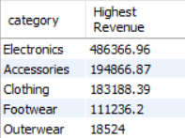
2.Are Discount Actually Increasing Purchased Value?
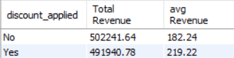
3.what is the total revenue generated by male and female Customer.
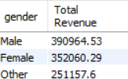
4.which customer used a discount but still spent more than avg purchase amount.
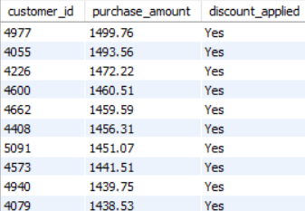
5.Which Are the Top/Bottom 5 Products With The Highest Average Review Rating.
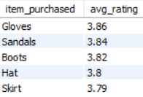
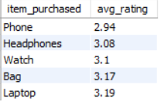
6.Avg Purchase: Standard vs Express Shipping
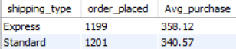
7.do subscribed customers spend more ? Compare average spend and total revenue between subscribers and non-subscribers
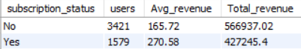
8.Top 5 products With Highest Discount Usage %
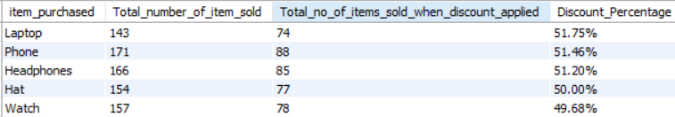
9.Segment customer into new,returning and loyal based on their total number of previous purchased and show the count of each segment
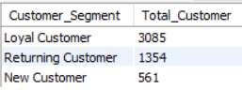
10. What are the Top 3 Most Purchased Products Within Each Department
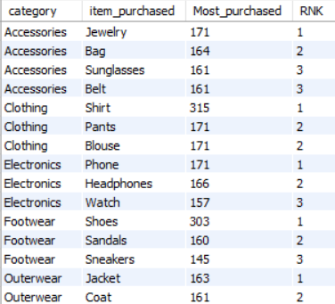
11.Are customers who are repeat buyers (more than 5 previos purchases) also likely to subscribe ?

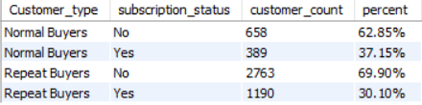
12.what is the revenue contribution of each age group ?
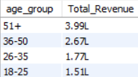

7. POWER Bi Dashboard.
